**CSE523 Machine Learning**

**Prof. Mehul Raval**

**Product Classification using their Ingredient**

**Week 5 Report**

| **Name** | **Enrolment Number** |
| --- | --- |
| Aharnish Pithva | AU2040022 |
| Jevin Jivani | AU2040051 |
| Astha Bhalodiya | AU2040067 |
| Yug Patel | AU2040181 |

**1) Tasks Performed in the week.**

During this week, we focused on implementing two machine learning algorithms, Naive Bayes and Support Vector Machine (SVM), as part of our project. Naive Bayes is a popular algorithm used for classification tasks, while SVM is a supervised learning algorithm that can be used for both classification and regression tasks. We applied these algorithms to our dataset and evaluated their performance to determine their suitability for our project.

**2) Outcomes of the tasks performed.**

Upon evaluating the performance of the Naive Bayes algorithm, we found that it achieved an accuracy of 93 percent. However, we concluded that this accuracy was not sufficient for our dataset, as it did not meet our desired level of accuracy. We then applied the SVM algorithm and obtained a significant improvement in accuracy, with a result of 95 percent. This indicates that SVM is a more appropriate algorithm for our project, as it has the ability to accurately classify a substantial portion of our dataset. The success of SVM can be attributed to its capability to identify the optimal hyperplane that separates different classes in the dataset with the maximum margin, leading to more accurate classification of new data points.

***Naive Base:***

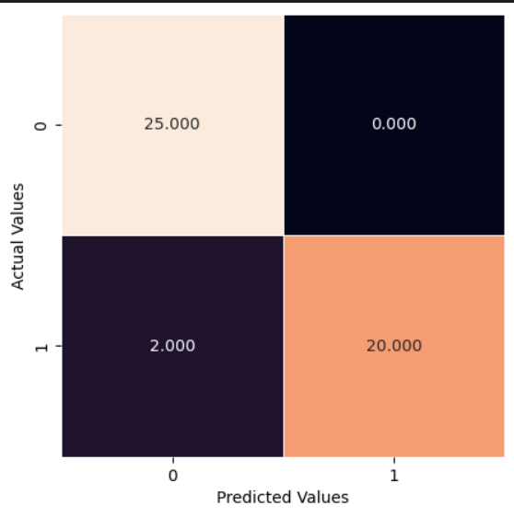

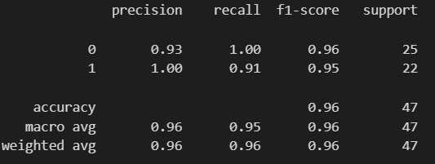

***SVM:***

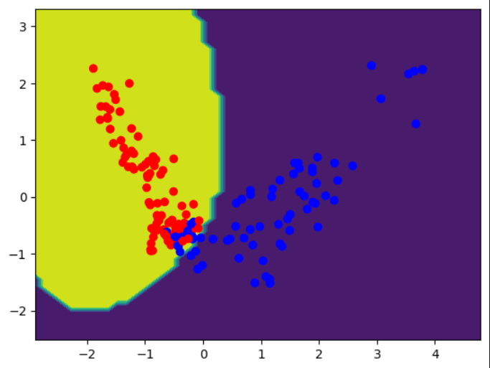

*Google Collab Link:*

<https://colab.research.google.com/drive/1B4VVYD9xcXuMN7twlAJxAZtQfCxo26AJ#scrollTo=Jv9SgBcv2HHx>

**3) Tasks to be performed in the upcoming week.**

Based on the outcomes of our evaluation, we have identified the need for more data to further improve the performance of our algorithms. Therefore, in the upcoming week, our plan is to collect additional data using the API key for chatGPT. We will then process this data to ensure it is in a format that can be easily utilized to enhance the performance of our algorithms. This approach is expected to lead to better accuracy and more reliable results in our project.